Adding Python Libraries needed

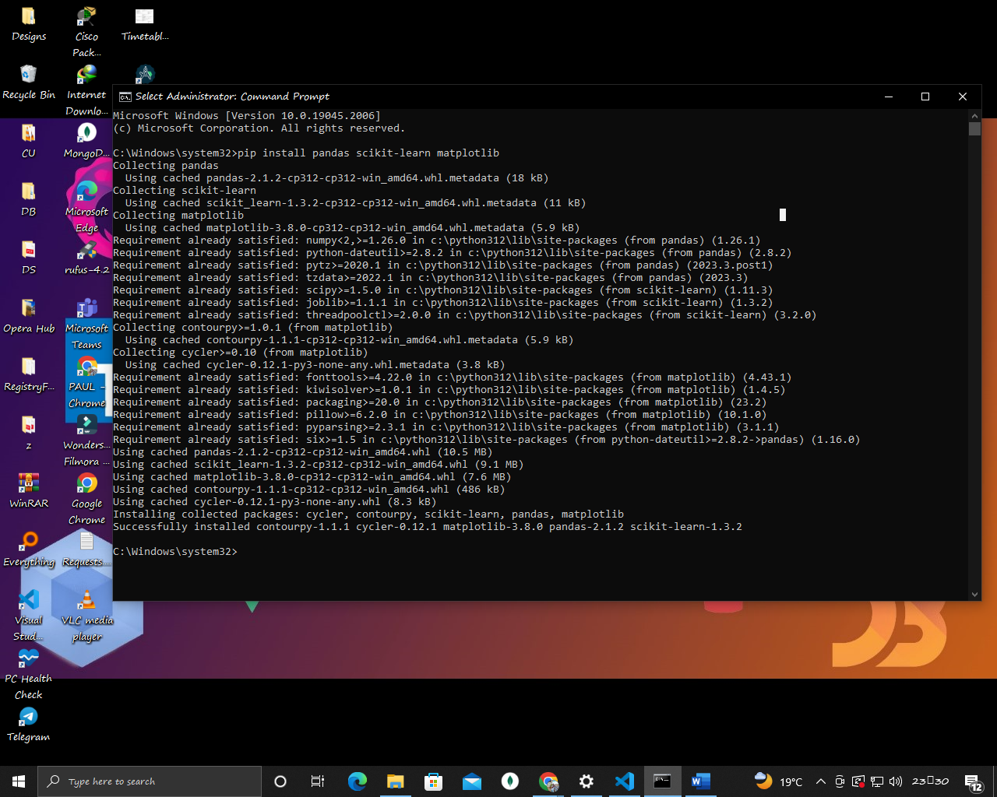

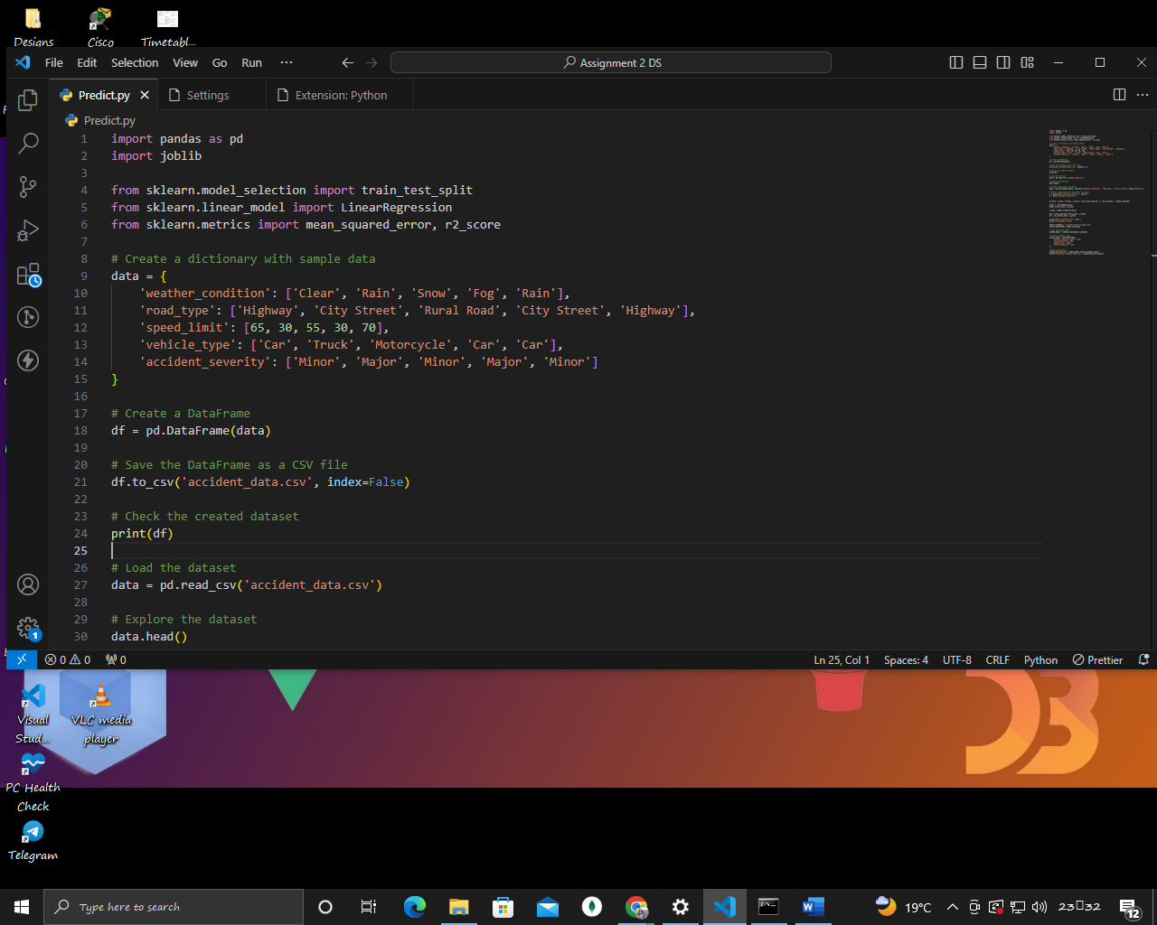

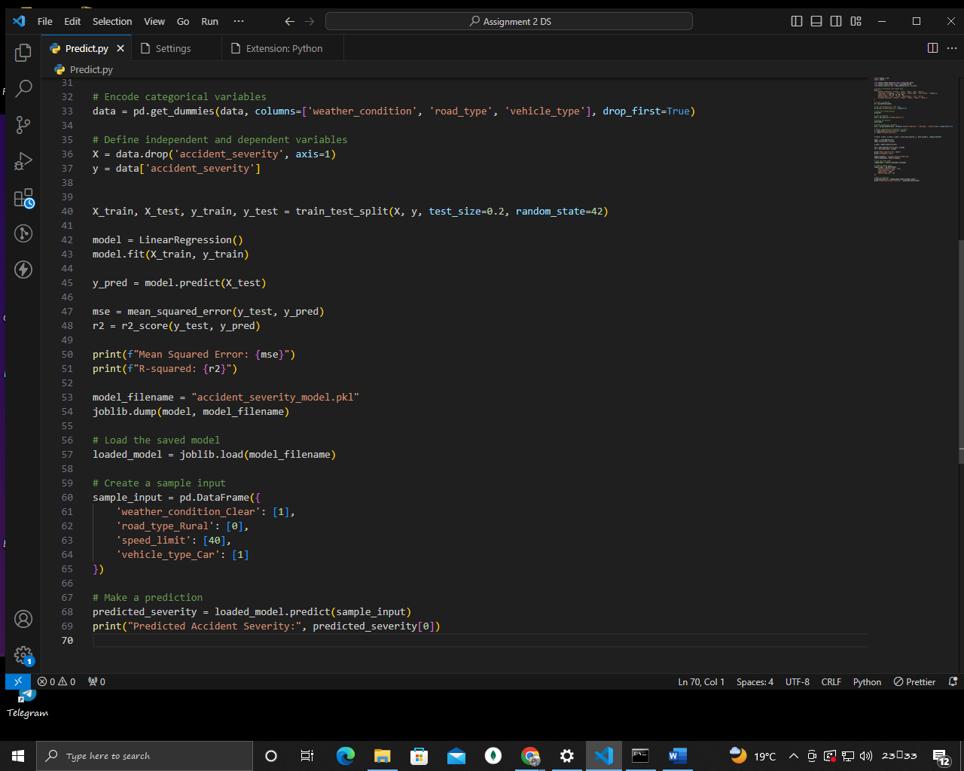

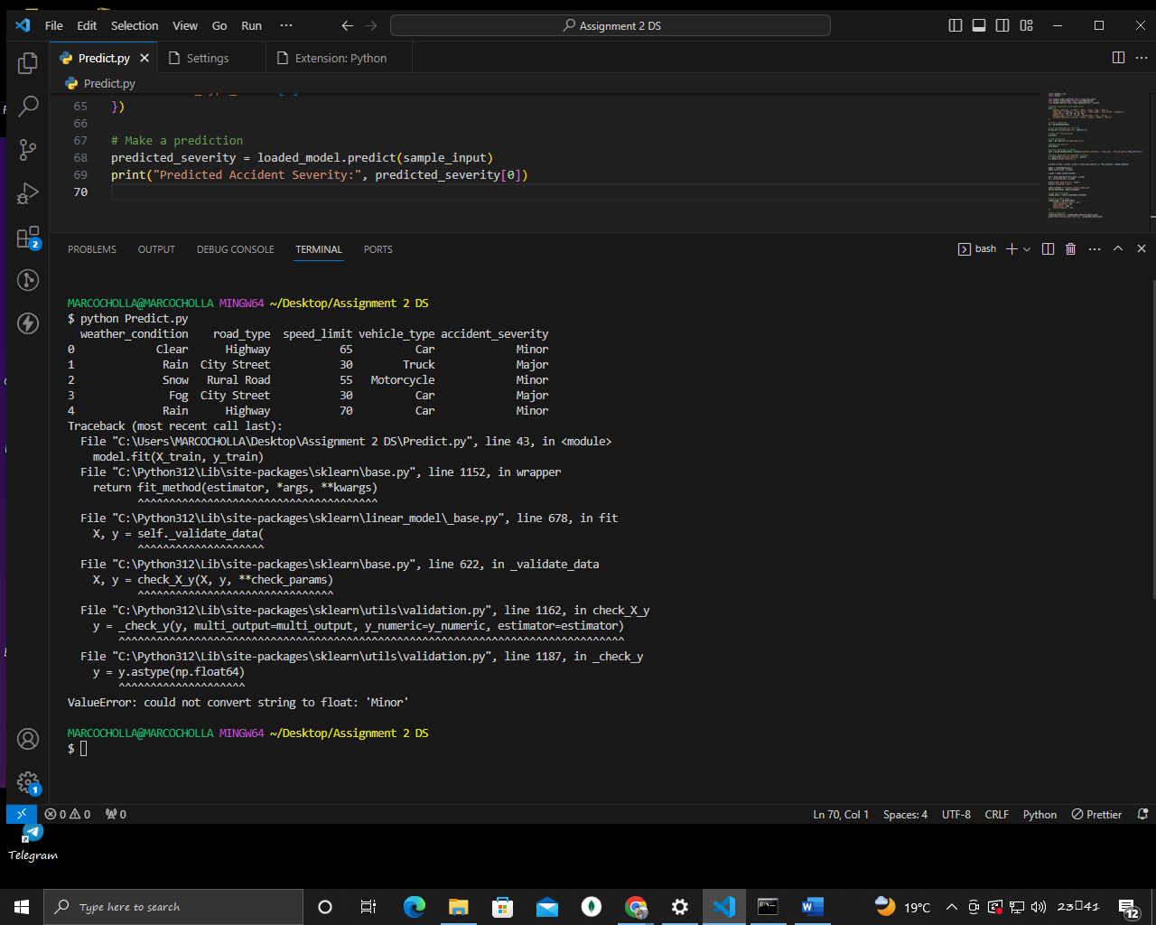

Benefit for Underdeveloped Countries:

Such a model can be beneficial for traffic accident analysis and prevention in underdeveloped countries in the following ways:

1. Resource Allocation: It can help governments allocate resources more efficiently by identifying factors that contribute to accident severity. For example, if road type is a significant factor, investments can be made in improving road infrastructure.
2. Safety Campaigns: Insights from the model can inform targeted safety campaigns. For instance, if weather conditions are a key factor, campaigns can focus on safe driving during adverse weather.
3. Policy Decisions: Policymakers can use the model to make data-driven decisions regarding speed limits, vehicle safety regulations, and road maintenance.
4. Accident Prevention: By understanding the factors contributing to accident severity, efforts can be directed toward measures that prevent accidents, such as improved road signage or stricter enforcement of speed limits.  
     
     
     
     
     
     
     
   GITHUB URL https://github.com/Marcocholla01/Accidenet-Prediction